Honors Algebra II
Unit 4 Solving Polynomials Review
Perform the indicated operation
1. $\left({5x}^{3}-x+3\right)+(x^{3}-9x^{2}+4x)$

3. $(x-6)({5x}^{2}+x-8)$

Solve the following polynomial equations.
5. $x^{3}+{5x}^{2}-9x-45=0$

7. ${-28x}^{4}+{7x}^{2}=0$

9. ${3x}^{3}-{5x}^{2}-3x+5=0$

Name ________________________

2. $\left(x^{3}+{4x}^{2}-5x\right)-({4x}^{3}+x^{2}-7)$

4. $(x-4)(x+7)(5x-1)$

6. ${3x}^{4}+{12x}^{2}=96$

8. ${12x}^{2}=108$

10. $x^{3}-{3x}^{2}-4x+12=0$

Divide the following polynomials.
11. $({2x}^{3}-{11x}^{2}+13x-44)÷(x-5)$ 12. ${5x}^{4}+{2x}^{2}-15x+10)÷(x+2)$

13. Given that x = -2 is a solution to the polynomial, find all remaining solutions of $f\left(x\right)= x^{3}-{5x}^{2}-2x+2$

14. Given f(8)= 0, find all remaining real solutions of $f\left(x\right)=x^{3}-{11x}^{2}+14x+80$

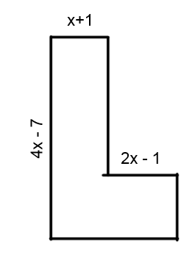

15. For parts (a) and (b), use the figure to the right.
a. write an expression for the perimeter of the figure.

b. Write an expression for the area of the figure.

